Tech Rider ~ Phoenix
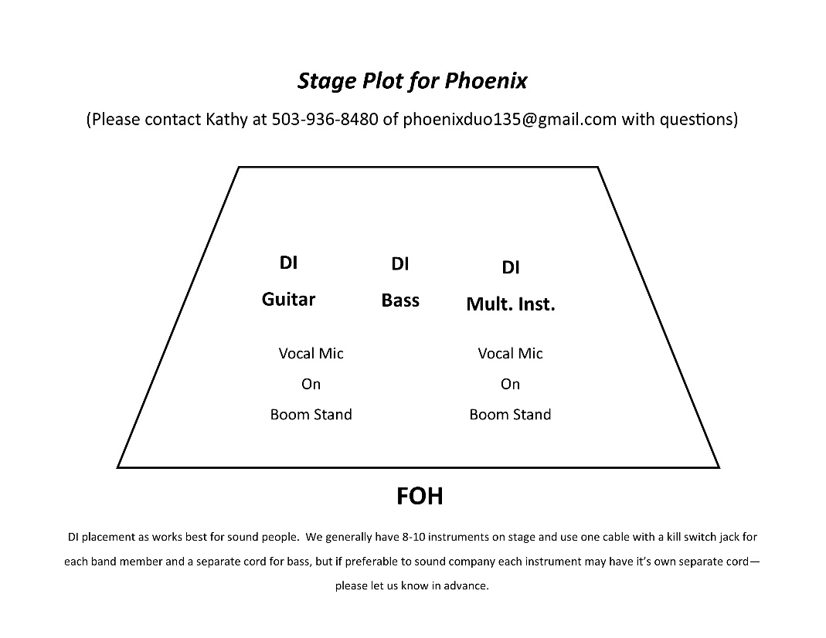

Tim Crosby (stage right) – Instruments will definitely include acoustic guitar; may also have a fiddle, banjo, octave mandolin, Hawaiian guitar. Kill switch cord (we supply) will be used on all instruments other than fiddle – which will be played through the vocal mic.

Kathy Crosby (stage left) – Instruments for stage are acoustic guitar, GS mini bass, and ukulele. Kill switch cord will be supplied by artist for guitar and uke – a separate cord and DI will be used on the bass due to volume difference.

Phoenix always travels with two vocal mics and three DI’s. We do not mind using the house equipment should the sound company prefer this. The duo also travels with their own instrument racks.

Please supply two boom mic stands.

Mix should be warm and in the mid-range. Kathy prefers her mic to be warmed up a bit, but not so much that people can’t understand the stage patter. Vocals should be louder than the instruments so the audience can hear what we are singing about. Instruments should retain their acoustic sound.

Monitors should be very similar to the house sound. Side monitors are always welcome, but we can go with what the house supplies.

Thank you for your assistance in making this a great show!

